Farming Connect Management Exchange

Nicola Lewis

Uk and Ireland

FarmEd - 20th May 2022

LEAF – 9th June 2022

Heather Hill Farm, Ireland - 12th and 13th July 2022

Background
I have a first-class honours degree in environmental sustainability with geography which has given me a passion for safeguarding the rural environment. For the last 15 years I have worked in regeneration and rural development.
I have been developing a 165-acre farm with my husband, where we breed Welsh mountain sheep, Welsh Mules and Welsh x Charollais, keeping around 350 sheep on a rotational grazing system, as well as having 15 acres of woodland.
From the management exchange I was keen to learn from farms that have established successful agri-environmental systems and on-farm education opportunities and see how silvopasture contributes to better environmental, economic and educational outcomes.

Itinerary
[What did you learn? Provide a description of your activities on each day of your visit and outline your key learning outcomes and knowledge gained]
FarmEd – Farm and Food Education – Agroforestry Open Day- May 20th 2022
The home of FarmEd is Honeydale Farm, a 107 acre (43ha) demonstration farm in the Cotswolds.
The farm is a diverse mix of low input arable and temporary grass, and organic permanent pasture. There are several trial plots which include sainfoin, herbal ley, barley, heritage wheat, wild bird seed and various cover crops. The grassland is managed by mob grazed sheep and cattle. Other features include a micro dairy, natural flood management scheme, a whole farm Countryside Stewardship Scheme, heritage orchard, tree planting, wildflower margins and an apiary.
The Agroforestry open day provided opportunity to attend a guided walk with the manger of FarmEd and the Woodland Trust.
As this is demonstration farm it gave opportunity to see the trials of the silvopasture system and to understand what works and what doesn’t. The farm takes risks for demonstration value to be able to share best practice to others.
In terms of silvopsture systems, the main learning outcomes from FarmED was:
- Have diversity in your farming system
- Understanding the barriers to tree planting on farms, some included:
  - Lack of knowledge of trees
  - Understanding the returns from tree planting
  - Cost to invest in tree planting
- Understanding the benefits of planting trees:
  - Alleys of trees between crops for protection and improved soil
  - Trees provide shade for stock
  - Support rotational growing systems
  - Shelter belt for crops – ecological feature
  - Connecting woodlands on farms for the benefit of wildlife
  - Improving the soil
- Understanding the types of trees that can be planted in system and considering things such as:
  - Planting trees that can be coppiced. First coppice is usually after 2 years.
  - Planting trees nontoxic to animals
  - Planting trees animals can eat and have benefit to their diet
  - Consider natural regeneration of trees rather than planting new ones
  - Understanding the types of trees and how fast they grow
  - Consider it can take 10 years before you have a tree
- Weed and pest control:
  - Sheet mulch – expensive but less labour intensive
  - Woodchip – a cheaper option but more labour intensive
  - Sheep’s wool is also a good weed control
  - Plastic tree guards are cheaper but not biodegradable.
- Opportunities for financial support:
  - The Woodland Trust provides funding to grow trees on farmland
  - FLAG fund shelter belts for ecological benefits.
  - There’s are sub leasing opportunities with forestry organisations.

LEAF (Linking Environment and Farming) – On farm Education discussion June 9th 2022
LEAF (Linking Environment and Farming) is a leading organisation delivering sustainable food and farming initiatives.
LEAF Education in partnership works to engage, inspire and motivate young people through experiential learning, in order to equip our future generations with balanced and informed insight into food production, farming and the environment. LEAF work across the education and agricultural sectors to mobilise farmers and educators to bring food production, farming and the environment into a learning context and embed an appreciation of farming into everyday life.
LEAF provided a day of information exchange, providing information on how to earn additional farm income by providing on farm education opportunities.
LEAF provides a significant amount of online material to support farm visits and provide an accredited farm education course for farmers to equip them to be able to teach.
Basic infrastructure such as washing facilities and toilets are required for farm visits.
Heather Hill Farm, County Donegal
Cathal Mooney is a regenerative farmer located in Donegal.
The farm operates a holistic planned grazing system and implemented a Silvopasture system and runs a on-farm education programme and he frequently runs farm tours/open days.
At Heather Hill Farm a holistic approach is taken with emphasis on meeting ecological, social and economical goals. They produce quality grass fed produce that improves the soil, adds value to the community and sustains the farm into the future, using a planned mob grazing, integrated tree systems as tools to ensure the soil is as healthy and productive as possible. These farming practices build the soil, improve habitats and leave the farm stronger and better for the next generation. Improving the soil is key to the farming practice.
The planned grazing system is turning poor ground into good quality grazing ground. This is achieved by goats, sheep and cows (herbivores) going through and eating as much vegetation as possible, without going down to the ground through grazing too hard. Once the herbivores are moved off the ground, they are followed by 200 chickens or turkeys (omnivores) and their portable sheds. The omnivores break down the manure from the herbivores and the manure from the chickens which are moved every 48 hours. No fertilizer or worm control is used on the farm under this system.
Also, the farming system doesn’t rely on farming subsidy. Careful business planning and regular budget reviews allows the farm to run in a profitable but sustainable way.

Next Steps
[What are you going to do next? You will have gained valuable knowledge on your exchange which should enable you to put some of your new ideas in to practice or make changes to how you run your business. Set yourself some action points and next steps to build on the knowledge gained on this visit and ensure it is put to good use]
All visits have been extremely valuable in order to move the farm forward.
Land has been identified on the farm where silvopasture systems can be implemented and we are looking to develop on farm education opportunities and plan to attend a LEAF course at the end of this year.

Key Messages to the industry
[A requirement of taking part in the Farming Connect Exchange was to bring back and share key findings with the rest of the industry on your return. Please list the key findings or messages you would like to share with the industry]
- Agroforestry/ silvopasture is still a relatively new concept in the UK. A key message/point would be – take advantage of demonstration farms as they are testing and taking the risks for demonstration purposes, allowing us to take best practice back to our own farms.
- Take time to look at your farm and look at options of how you make the most of every acre, taking a holistic approach to your farming system.
- On-farm education opportunities can provide extra income for your farm.

FarmEd
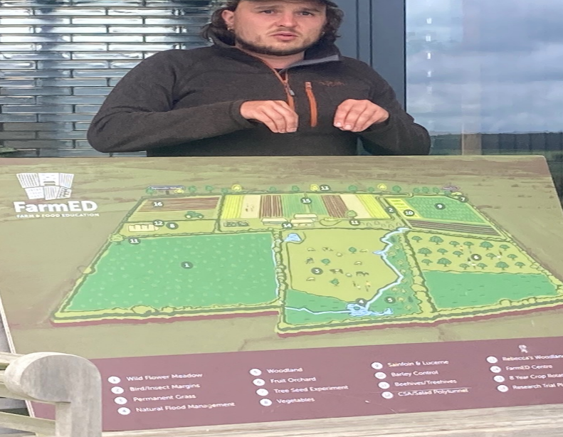
Picture 1: This is a plan of the trial plots at FarmEd.
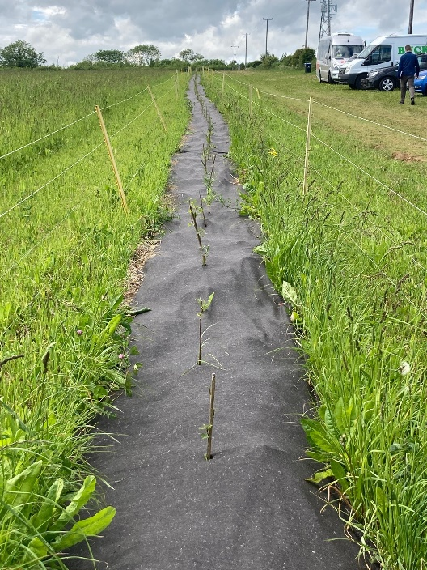
Picture 2: A recently planted row of trees that forms part of the Silvopasture system on the farm.

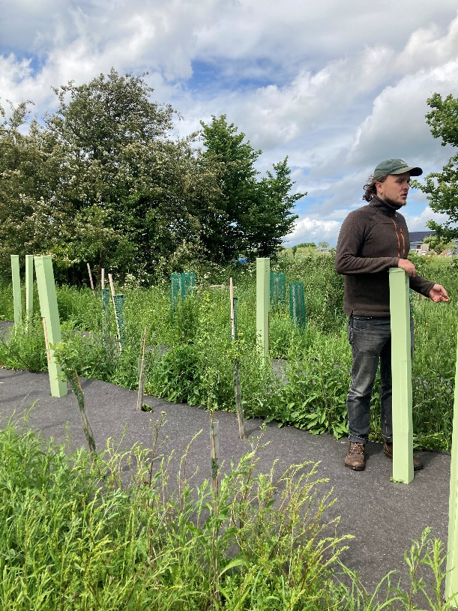
Picture 3: This area demonstrated the different types of tree guards that could be used.

Heather Hill Farm, County Donegal
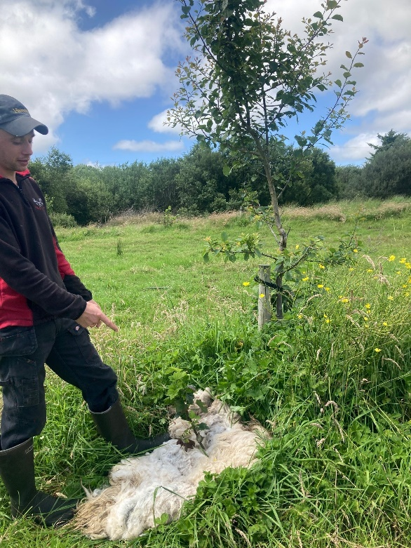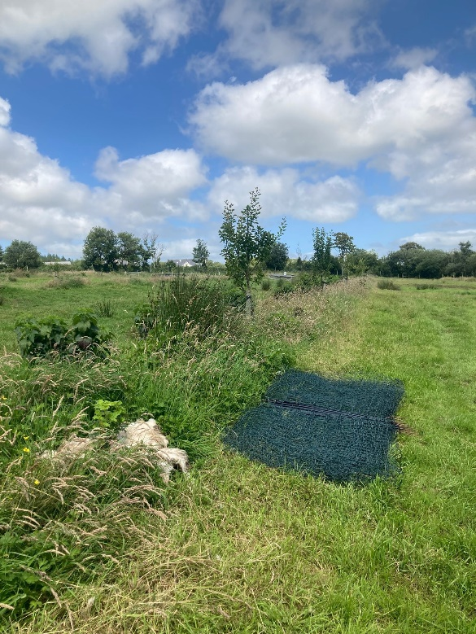
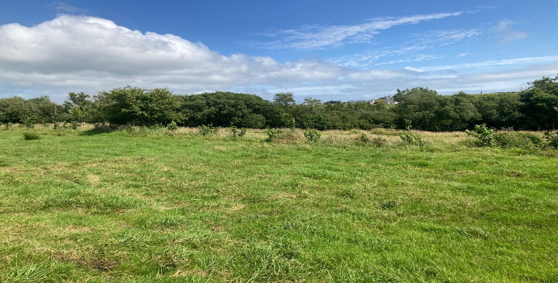
Pictures 4, 5 & 6: Examples of a silvopasture system and how sheep’s wool is used for weed control.

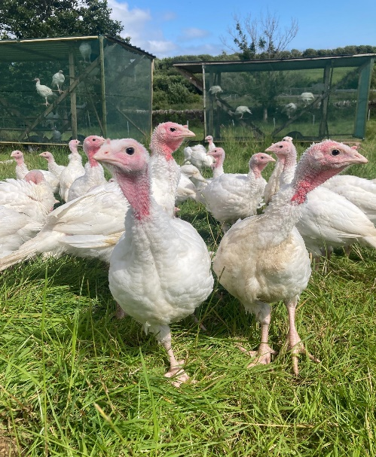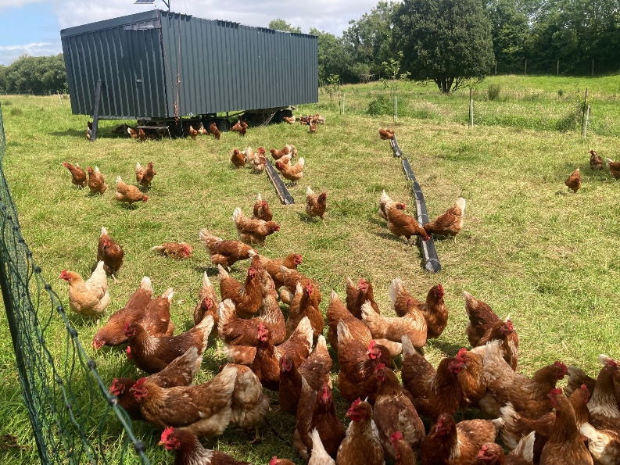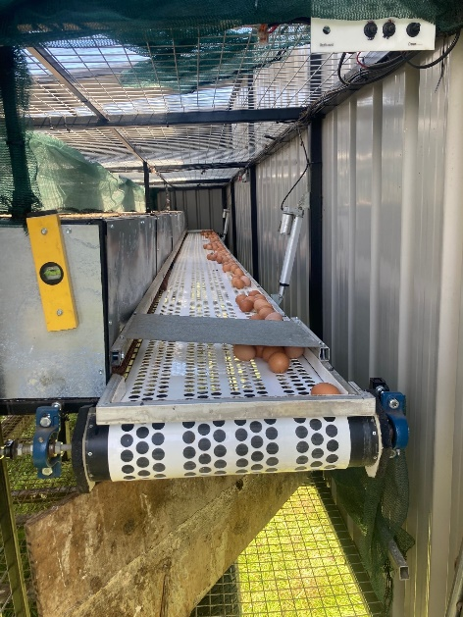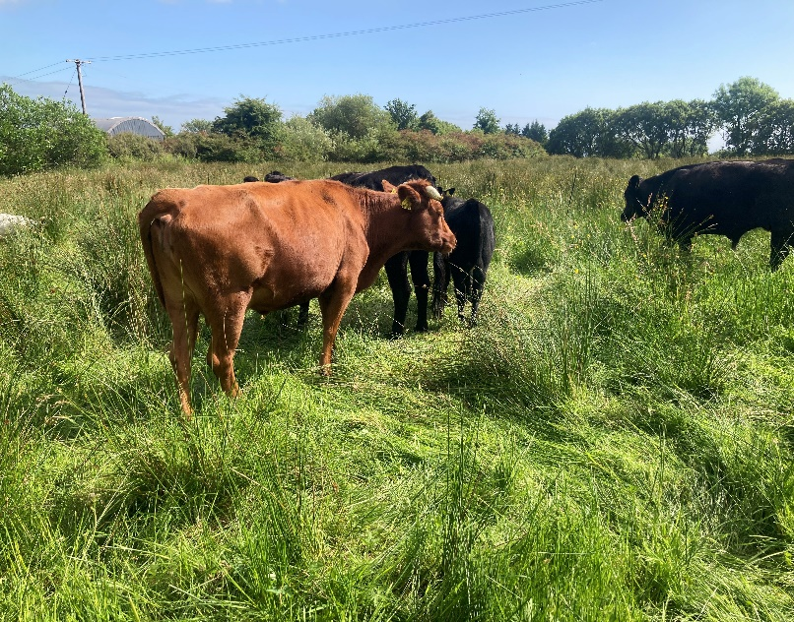
Pictures 7,8,9 & 10: Some of the examples of livestock integrated into the holistic farming system and form part of the mob grazing plan.

