Jamie McCoy – Management Exchange – Netherlands and Austria, 2022
Cow bells, clogs and cycling!
I’m Jamie, and I farm in Ceredigion with my partner Deian. We milk 200 cows on an Autumn block calving system, keep 150 breeding ewes and among other things we offer farm stay accommodation in our home, have a PYO pumpkin field, and have recently diversified into selling pasteurised milk through vending machines in Newcastle Emlyn and Cilgerran, branded as Llaeth Gorwel. Our best diversification to date is probably our time – I work full time for AHDB Dairy, and Deian likes to step away from farm routines occasionally too for a bit of variety when workload allows. He set up a wood chipping diversification and even took a sabbatical to travel to Antarctica and work for British Antarctic Survey.
Setting up the vending machines has highlighted to us that getting closer to the customer can increase returns financially, but also the reward can be great in terms of product feedback too. I’m a firm believer that diversifications should only be established to compliment existing enterprises, and must spin from a strong base. Experience has show that those which are started in attempt to support a struggling business are less likely to succeed. I am incredibly grateful to Farming Connect for accepting my application for the management exchange. It’s not only the funding which made my trips to Austria and The Netherlands possible, but participation made me prioritise the travel, set a deadline for completion and forced me to consider carefully my learnings and set them out to share. I hope in reading this I can show a little about what I saw and learnt, and perhaps even inspire a similar trip of your own.
I set out to look at supply chains, for the plethora of agricultural products we have on Welsh farms, from meat and milk, to wood and wool, plus also the experiences we could offer. Direct selling challenges we have come across ourselves include finding cost effective and available packaging, identifying and accessing customers, and I’d like to further explore how we can improve links with tourism.
Labour is an ongoing challenge and whilst opening a farm shop might be a dream of mine, I know that to set up something similar would make us vulnerable to the challenges of staffing such an enterprise. Vending machines seem an obvious answer, and one we are persuing, but they are not as integrated into British culture as they are in Europe, and here can be associated with lower value products – I remember from school days the vending machines in the school cloakroom stocking stale sweets and fizzy pop and if you gave them enough of a shove you might get lucky and get a bonus packet of crisps drop!
Coming back to tourism, there are a number of agricultural sectors which are better associated with exclusive luxury experiences than perhaps a Welsh dairy farm conventionally provides – think French vineyards and cheese caves or Swiss chocolate! I wanted to look at how to access a more high-value market, and consider how we can move from commodity trading, as price takers, into a higher valued product, possibly even becoming price setters, and perhaps even how we might profit from sharing our beautiful Welsh way of life with visitors, or creating experiences which would be sought after and valued highly.
My title ‘Cow bells, Clogs and Cycles’ is slightly tongue in cheek, but the cultural context is important to understand. Over my time travelling I managed 3 Dutch dairy farms, 1 egg producer, 2 vineyards, 1 mixed fruit farm, 1 camel farm, 6 Austrian alpine dairies, numerous cheese shops, plenty of farm shops (both scheduled and opportune visits) and an unimaginable number of vending machines – I surprised myself how many I managed to find or fall across!
As I landed in Schipol airport I could see cows from the plane, quite literally grazing right up to the boundary of the airstrip, and I wondered wether any ever hopped the ditch and ended up on the runway. The airport itself is adorned with pictures of cows and contains so many vending machines selling any number of things from face-masks to electricals I lingered in the airport to start my study!
The cow is part of Dutch culture – and they are currently facing some policy changes which is throwing the future of many dairy farms into question. Many are housed year-round, and milk through leased robots, and new regulations associated with water quality (similar to our NVZ’s here) mean that great numbers of cows may need to leave the system. Farmers explained to me when I attended social BBQ arranged by a local farming union branch that reducing cow numbers further will mean they won’t be able to afford the lease on their robots, never mind leave any profit for them afterwards.
In the Netherlands, where the land is completely flat and much of it below sea level, the bicycle is a primary mode of transport. There are 1.3 bikes per person in the Netherlands – and that’s for a population of approximately 17 million. Shoppers use their bikes to travel. A conversation with one farm shop owner highlighted that a car arriving correlates with a higher basket spend, because it usually means they brought car out of necessity, as they will buy more than they can carry on a bike. Incidentally, the car parks at the farm shops are really quite small.
In Austria the bikes were fun focussed and many of them were electric – the landscape could not be more opposite from the flat of the Netherlands. The Brengenzerwald area which I visited is one of the most beautiful places I have ever been (yes, I have been to NZ, so I appreciate what a big statement I am making in saying so!).
Austrian industry appeared to be timber, tourists and dairying in the region I visited, but a quick google search highlights that Austria is synonymous with luxury goods and also engineering which is important when considering vending machines as the engineering is more available than it is currently in the UK. When asking in both Austria and the Netherlands where they purchased their vending machines the answer was always locally, and the service was never a challenge.
Austrian farmers milk the cows from a housed base in the winter, located centrally in ski resort villages, housed in the same building as the feed store, and family home, built entirely from locally sourced wood and crafted with such care the resulting buildings are absolutely gorgeous. In the summer the same cows head higher into the herbal pastures of the mountain, where they are milked by a different team of people who look after the stock and process dairy products all in situ up the mountain, well off the beaten track, and certainly miles from a milk tanker route. At the same time a separate team are down at the homestead preparing for winter – making hay daily and of course many other jobs. The surprise here is that two families can be entirely supported by just 20-30 cows – not your average welsh scenario.
The cows wear bells, but the temporary electric fences showed that their grazing is carefully planned and farmers are unlikely to have to listen for them across the mountain. The sounds of goat and cow bells ringing is amazing, with each bell having a different tone, and it certainly adds to the visitor experience although I think that is more accidental heritage rather than deliberate.
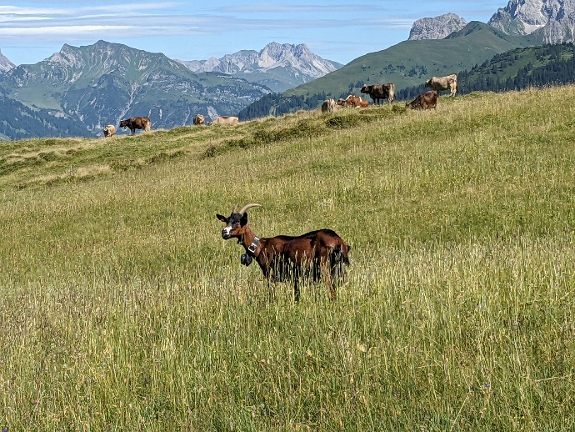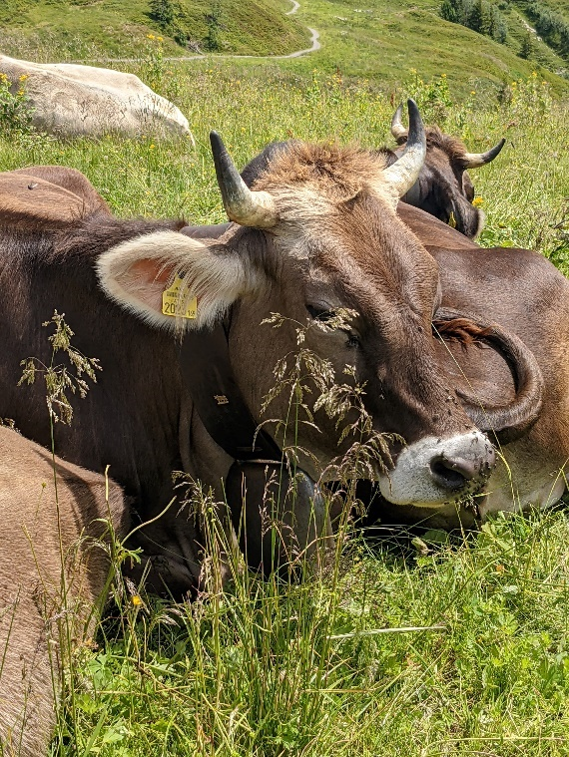
One farmer at the lower homestead had unusually kept a few cows back from heading up - ‘crooks’ as he called them. One older cow, one slightly (minorly) lame and one who had headed off a ledge last season and needed to be rescued by helicopter so was no-longer trusted up the mountain!
The Alp’s are a playground for skiing in the winter, and hiking or mountain biking in the summer. You ride the ski lifts to access a great number of trails, all of which interweave through alpine dairying. These ‘Alphaus’s’ serve passing visitors with dairy products made on site. Herds are an average of 20 cows, and the milk is served to passing walkers and cyclists as milk, milkshakes, yoghurts or even cheese which is made on site. I paid around Euro 2.50 for a 300ml (ish) glass of milk.
Some of the alpine huts also had goats and pigs too. The pigs feed on the whey from the cheese making process, or any other surplus available. Turning dairy waste into meat there is little overall waste in the system.
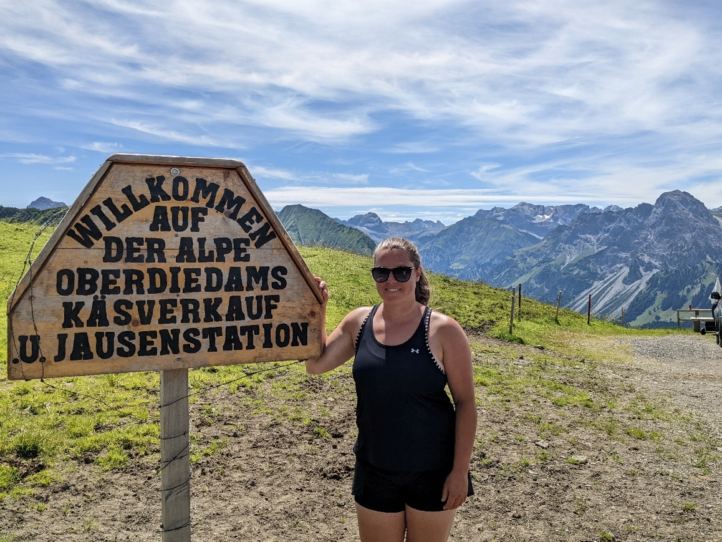
The Alpine pasture was a real fascination – I couldn’t identify half of the plants growing, but it was vibrant with flowers, herbs and riddled with butterflies. This was a USP for the region, and down the mountain at the larger cheese shops they sold cheese rolled in the ‘Blooms’ and another variety coated in the ‘Herbs’. They have a European label dictating that they don’t use any silage making practices in their production (associating silage with acidosis) – winter fodder is all herbal hay which is collected in a wagon or by hand, and conveyored into a hay loft loose, or forked by hand.
I was lucky enough to observe the hay-making process, using slope tractors – only slightly bigger than a quad bike but operating kit both front and back. These machines appear infinitely more efficient than our own heavy machinery. They also operate using one axle for a number of implements, which when out of use are then jacked up on stilts until the next time when they reverse the axle under again – so just the one set of wheels for multiple farm implements from slurry tank to hay wagon. There are lots of jobs done entirely by hand, where larger farms would by now be mechanised, and in the Austrian families I met the women were as equally as involved in farming as the men.
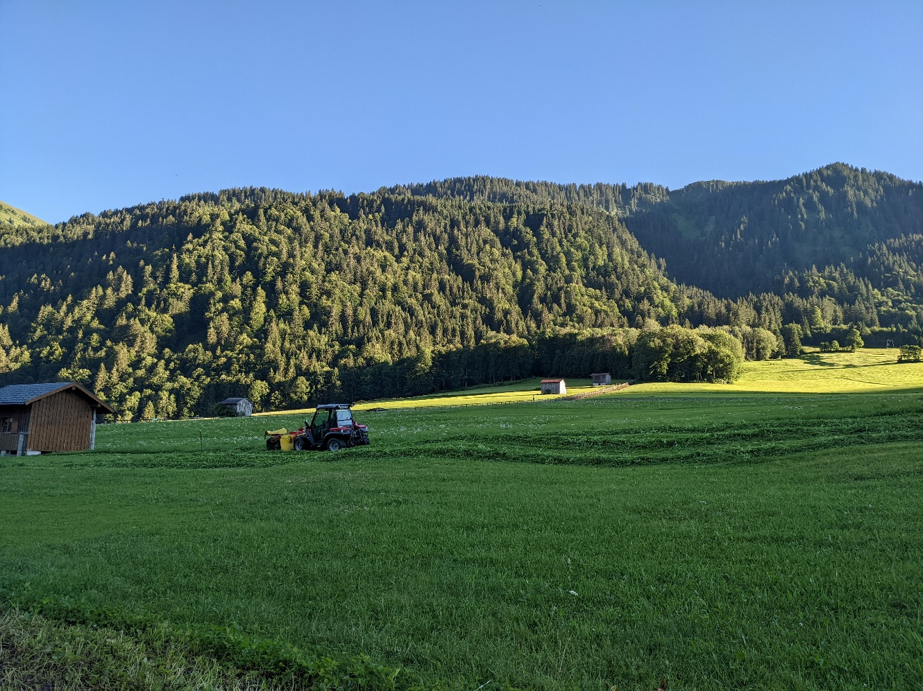
One message which came across particularly strongly in the Netherlands was about carefully planning your time. Farm shops had short opening times, or limited days trading. This allows them to operate at lower staff levels and keep visitors to the farm to specified time periods. The camel farm only sold fresh milk daily in the morning between 8am and 9am. Customers had to fit in with that schedule, or buy frozen online. Whilst camels milk products are particularly unique, I was surprised to hear how global their market is and how far people travel (over international borders) to purchase, and then with such limited open hours the customers (separate to their farm experience opening hours) really had to make an effort to buy – and yet they did go to great lengths for the product and were happy to do so.
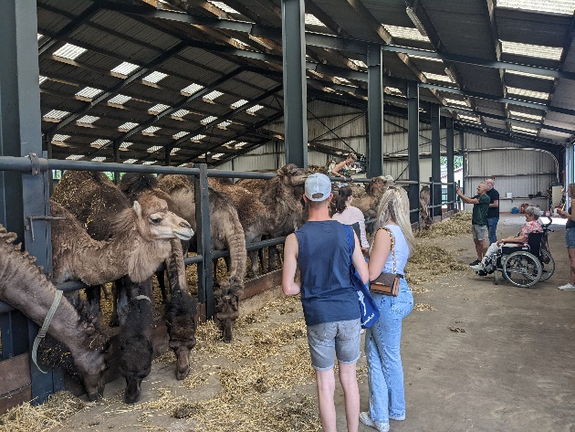
This was a fascinating visit as I was able to see the merging of both a unique raw product, plenty of added value supply chains, and a visitor centre entirely focused on experience. This farm was spawning other products originating from milk, such as liqueur, soap and health products. The farm is currently exploring the role of camels’ milk in helping speed up recovery from long covid, and whilst no claims can yet be made, anecdotally it appeared they may have a new USP! I was interested to learn that most of the processed products were being made by third parties or other businesses. When you search for camels milk Europe (which incidentally is mentioned in Qu’ran) online, the Smit’s camel farm is one of the highest ranking - they believe this is vital to their business, especially the mail orders.
Another Dutch farm shop was only open on a Friday and Saturday, and it appears this was usual – they found condensed open hours didn’t affect sales, just concentrated them into a shorter period, and allowed lower stock wastage. This also means they can attend events and fairs on other days as and when the opportunity arose, and helped with time management overall. One place visited had a very open policy to allowing customers to wander freely on the farm – unhosted vistors were able to visit the paddocks, the farm buildings and walk among the machinery, plus observe cheese being made through glass panels. I believe this to be positive overall, as industry transparency appeared greater and the rural/urban divide much less, however this level of openness comes with some serious responsibilities to protecting industry reputation, health and safety, animal welfare and food hygiene. I don’t feel certain that such a casual approach could be taken in Wales, especially where the visitors themselves may not have had the agricultural exposure and may not be so well educated on how to behave responsibly on a farm.

Opening times of the alpine huts in Austria was dictated by the ski lift times for the most-part, as walkers and bikers touristing in the area were generally off the mountains by the evenings, but I suspect by the nature of the businesses there they would help anyone at any time of day due to the remote location.
Vending machines can offer a 24 hour service in the right location, and can be much cheaper to rent the space needed than an entire shop. This was one of the main advantages discussed with many businesses in both Netherlands and Austria, and I saw occasions where neighbouring farmers were hosting each other’s machines in order to increase the number of product lines available at each place, and therefore become a better draw for customers. For those located in strong tourist areas they mentioned that as people arrive at self-catering cottages often they don’t carry supplies with them, and will stop off for breakfast or dinner supplies from a local vending machine as they check-in. Machines were stocked appropriately to cater for this. Dutch favourite items to stock included eggs, milk, yoghurt and pancake mixtures. In Austria, common items were cheese, butter, milk, German sausages and pate style products. Additionally, many of the direct sales site, were honesty boxes (or fridges) rather than necessarily all operating automated payment options, although many did take both cash and card payment.
Roy’s Automart egg shop, despite being unmanned, closed nightly in order to prevent any late call outs, especially to protect family time. The shop, although totally automated is close to their home and the closed periods allowed them to protect their privacy.
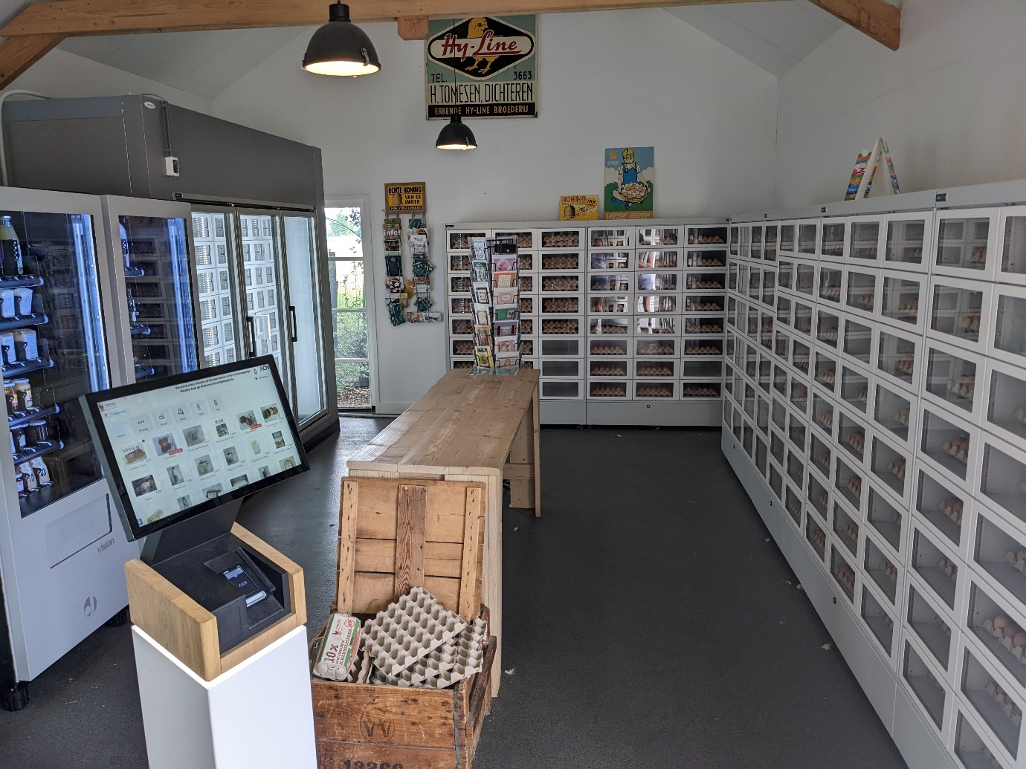
I noticed that in The Netherlands and Austria customers seemed more willing to purchase single products at a time rather than do an entire shop in the supermarket, although in both countries I did visit supermarkets. In both places the displays were more varied, appeared more local and perhaps could be described as more rustic than our own supermarkets. For example, the cheese selection was huge, taking a far bigger proportion of the shop than it would in the UK, and representing what an important part of the diet dairy forms. The Dutch have the 3rd highest dairy consumption per capita in the world, with Switzerland ranking 5th (the exact area of Austria I visited was immediately bordering Switzerland). By comparison GB ranks 24th in the world. Particularly baked goods appeared much fresher – in an Austrian Aldi there was a machine where you could vend fresh, warm baked goods.
At the opposite end of the luxury scale in the Netherlands there is a fast-food chain (hotdogs and fries) called FEBO where the kitchen is at the back of the store and alongside a normal serving area sits warmed locker vending for the same produce. A short observation of customers in the Amsterdam branches soon showed that some customers preferred the service provided by a human, but others chose to avoid any interaction and served themselves from the locker vending machine for a swift takeaway. This theme was revisited a number of times during my travels – not every customer wants to have an interaction at every purchase. I suppose it’s not a huge step from the trend of pre-ordering online, or at touch screens before collecting your food, as is becoming commonplace in MacDonalds.
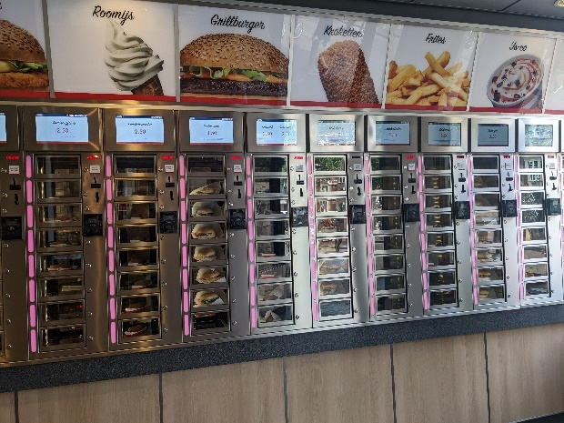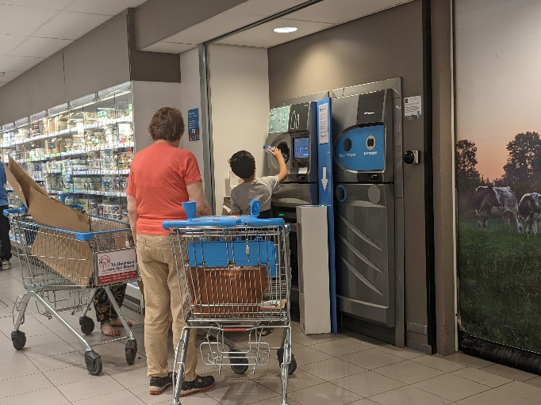
In both nations shoppers returned plastic bottles to supermarkets for recycling, feeding them into an automatic machine, and then received a payment back. Perhaps this makes the idea of purchasing a glass milk bottle to reuse, (as our Welsh customers do for our milk vending machine) more a way of life than it is currently in Wales.
My final comment will be on customer service and experience. At numerous cheese caves along the KasseStrasse cheese trail I was offered delicious tastings, had pairings recommended and whilst the language barrier was at times challenging, I understood they cared about my experience as a customer. Observing farmers checking their vending machines, when customers arrived they lingered to check if the customer wanted to chat, and to check that they technology worked successfully (just in case).
In Amsterdam I enjoyed pancakes for lunch. The service was excellent, the food good, but what makes it most memorable is that as I settled the bill I was given a small keyring with a tiny wooden clog containing the restaurant’s logo. This trinket, which probably only cost pennies to produce, now serves as a reminder of the experience, and it certainly secures them my custom again if I ever return to Amsterdam. Maintaining customer loyalty is important for Welsh brands and I now need to explore what options I could persue to do similar. Perhaps it will be prize giveaways, bespoke packaging, or a stamp visitors can collect in a passport as they head along a foodie trail from vendor to vendor in Wales? Perhaps it will be prize competition or QR codes to scan at the machines to learn more about the provenance.
This study leaves me with a whole range of ideas to develop, plenty of which have not fit into this report. I will no doubt persue or disregard lots of my ideas formed during my trips, and have some key decisions to come about how best to go about the process to explore working with other Welsh producers and perhaps ‘Visit Wales’ to establish links (maybe even KasseStrasse style cycle links!) between food producers.
PS. Whilst travelling I posted mostly on Instagram during some of my visits – do follow me @gorwelfarm, or on twitter @jamiegorwelfarm plus we have Llaeth Gorwel page on facebook.
Summary
Participation in the management exchange has been an enjoyable and influential experience and I am grateful to Farming Connect for providing the opportunity. I have found some key learnings which are included in this report, however there are a plethora of things which I also observed which need further time to research, or for me to consider applicability to a Welsh scenario. There have been some changes I have been able to embrace immediately and some which will take longer to implement. The process of visiting other businesses has also served to nudge me on a few things I was already considering, but didn’t have the confidence or urgency to persue. Special mention must go particularly to three of my hosts for such inspiring and interesting visits – Djuke van der Maat, Roy Tomesen and Dorieke Goodijk all went above and beyond in their hosting, connections and information sharing – Diolch yn fawr iawn! I am indebted.
Changes made already as a result of participation in the management exchange
- Ordered bottle labels for smaller bottles which to date I have been selling unbranded, as a result of seeing a more cost-effective option to that we which I use on our 1 litre bottles
- Purchased a second-hand vending machine with the view to increase products available
- Made connections with 3 other local food producers to explore opportunities to work together
- Increased fridge capacity as the opportunity arose with the view to further develop the Llaeth Gorwel customer base
Actions to take in the short term
- Considering a new site for placing a milk vending machine in order to maintain a greater share of the takings – currently our machines are located in retailers, which has advantages, but also comes at a cost
- Improve social media presence and audience engagement – consider competitions etc
- Increase the profile of the machines with local audiences and how to communicate with tourists
Changes / developments being considered for the medium to long term future
- Consider how to form a network for vending machine owners in order to benefit from bulk buying, joint advertising etc
- Approach tourism board to consider the possibility of creating a trail between existing vending machines
- Consider how to develop further the customer experience at our pumpkin field
- Look at options to host visitors on our farm

Key learnings
- Don’t be afraid to charge a fair price for your product
- Customer experience is vital
- Vending machines can become part of shopping culture
- Short supply chains can be rewarding for both producer and customer
- Make the most of the customers you have access to, and specifically cater to their needs
- Tourism industry, alongside food and drink are integral to agriculture and those links can be better exploited
- Branding, labelling and telling your story well can add value to your product, or enhance customer experience
- Search engine understanding and optimisation is vital for sales online
- Having a unique selling point will help move your product from commodity to luxury
- Opening hours need to fit in with your business and life commitments

